


Demandware Implementation Guide
Merchant Services
1/4/2016
Version 15.1.0

DISCLAIMER: This is an internal document of Kount Inc. Distribution to third parties is unauthorized. Kount Inc. believes this information to be accurate as of the date of publication but makes no guarantees with regard to the information or its accuracy. All information is subject to change without notice. All company and product names used herein are trademarks of their respective owners.

Copyright © 2012-2016
Kount Inc.
All Rights Reserved

Contents
Overview 5
Summary 5
Requirements 6
Requirements 6
Functional Overview 6
Limitations / Constraints 6
Compatibility 6
Privacy, Payment 6
Cartridge Stability 6
Kount Environments 7
Integration Certification 8
Logging 8
Implementation Setup 9
Configuration 9
Step 1 – Site Import 10
Step 2 - Create Services 12
Step 3 - Kount Site Preferences 13
Step 4 - Assign Cartridge to Site 16
Step 5 - Modify Storefront Code and Pipelines (Custom Coding Requirements) 17
Step 6 – Configure the Event Notification Service (Optional) 21
External Interfaces (Communication between Kount and Demandware) 22
User Defined Fields Setup and Configuration 22
Configuration of User Defined Fields (UDFs) within Kount 22
UDF Settings within Demandware Custom Preferences 23
Modifying UDF map within Demandware 24
Error Logging and Notifications 25
Appendix A: Upgrading/Updating the Link Cartridge 26
Appendix B: Demandware Order Workflow 27
Kount Review/Escalate 28
Kount Approved 29
Kount Decline 30
Appendix C: Test Cases 31
Verifying the Functionality of the Cartridge: Test Cases 31
Appendix D: Legacy Certificate Creation 39
Firefox 41
Certificate Request: 41
Certificate Export: 42
Appendix E: Manual Integration Steps 45

Overview

Summary
Kount is a leading innovator of solutions for fraud and risk management. Kount's “decision engine” platform is ideal for managing fraud in online/telephone channels that process payments and onboard new customers. Kount is committed to offering an end-to-end, single-source solution focused on speed, simplicity and ease of use...with a no-compromise approach to providing real-time accuracy in results.
The Kount Demandware cartridge will provide rapid integration for Demandware implementations. The Kount cartridge is a self-contained cartridge that can easily integrate into any project. This cartridge can be configured in the Business Manager and contains all elements necessary to perform a successful best practices implementation of Kount.
Kount aggregates and evaluates data from three primary sources, the Data Collector (DC), the Risk Inquiry Service (RIS), and the Kount Persona technology. From these three sources Kount provides a risk score and a response based upon merchant administered rules.
The Data Collector gathers information from a customer’s device by redirecting the device browser momentarily to Kount then back to the merchant. This passive analysis obfuscates Kount’s interaction with the customer and does not affect the customer’s purchasing experience.
The Risk Inquiry Service evaluates the data provided by the Data Collector and the order-form data submitted to the merchant from the customer to create a fraud score. Merchant specified rules are assessed for each transaction during this evaluation process.
The Kount Persona is comprised of linked data points across the breadth of Kount merchants which provide behavioral analytics related to a transaction.
The Demandware Workflow Diagram provides an overview of how a transaction flows through Demandware when the Kount Demandware Link Cartridge is enabled.
The Kount Demandware Link Cartridge is written by a third party development firm, support and point releases are ongoing. If additional Link Cartridges or customizations have been added to your instance of Demandware, conflicts may occur and may result in additional support and/or maintenance fees outside the Kount standard integration.

Requirements
- All steps from UX Studio Installation & Sandbox Setup Guide (from Demandware) have been completed
- A Demandware Development Resource: The Integration and installation process includes deployment of a generic cartridge and modification of storefront code & pipelines.

Functional Overview
Kount Link Cartridge includes:
- RIS (Risk Inquiry System) HTTPS Post
- Device Data Collector implementation within checkout process
- Supported payment types:
  - Credit card type
  - PayPal
  - Gift Certificate
- ENS (Event Notification System) update to Demandware instance
- UDF (User Defined Field) Support
- Device Data Exclusion Array (Support for Phone Orders)
- Multiple Websites
- Email Notifications for Errors, ENS and Risk Change Events
- API/RIS Key (in lieu of older Certificate/Key configuration)

Limitations / Constraints
- No AVS or CVV information has been passed
- Only listed payment methods will be sent to Kount
- Only Post Authorization configuration

Compatibility
Cartridge designed for Demandware API version 15.9 and Kount version 0630. (A previous version of the Kount Link Cartridge can be obtained for 14.1 version of Demandware if needed.)

Privacy, Payment
Kount supports different payment types and depends on chosen by the customer payment type (payment tokens are required). If chosen payment method not supported by Kount, then a value of NONE should be passed.
The integration uses customer profile data, and transfers it to Kount. Hashed credit card data is sent to Kount system. The following credit card data is sent:
- Hashed Credit Card Number (using KHASH - Salted Irreversible Hash; PCI Level 1 Compliant)
- Customer Name on Order
- Credit Card Type

Kount Environments
Kount has separate environments for testing and production. The initial integration will first take place in the Kount TEST environment. Boarding documents containing the information for the TEST environment are contained in the “Welcome Email” provided to a merchant when they begin the boarding process with Kount.
The test environment is not engineered to support load testing; it is designed primarily to verify connectivity and proper data submission. Many features such as order linking, scoring, device location, and persona related information are disabled or limited in the test environment.
- Test credit cards can be passed into the test environment but will fail in the production environment.
- Port 443/HTTPS is required for submission and receipt of data in both the test and production environments.
- API Keys are required to authenticate to Kount. Each environment requires a separate API key.
  - API keys are created within the AWC (Agent Web Console). After logging in, browse to the Admin tab -> API Keys -> Create API Key.
  - Check both the RIS and API checkboxes when creating the API key.
  - The API keys must reside on each server that is posting to Kount.
NOTE: API Keys are specific to each environment; Keys created in the TEST environment will not work in the PROD environment and vice versa.

Integration Certification
Upon verification that the correct data is being passed for both the Data Collector and Risk Inquiry Service the merchant will be issued a Certification Letter along with an additional boarding document providing the Production environment information.
Any customized data created in the test environment will have to be re-created in the production environment, this includes, users, rules, site IDs, user defined fields and API keys.
The test environment will continue to be available to the merchant for testing purposes but should not be used with production traffic from the merchant.

Logging
To facilitate troubleshooting ensure that logging is enabled in the Demandware Link Cartridge. Errors from the Kount Link Cartridge will be logged into separate log file.
Logs are located Administration > Site Development >Demandware Development Setup. The Log file naming convention is:
custom-Kount-blade0-4-appserver-<date stamp>.log

Implementation Setup
The int_kount cartridge is required for the integration. Please obtain the cartridge from your Kount Technical Account Manager, if you are not sure who to contact please email support@kount.com.

Configuration
There are 6 basic configuration steps:
- Import kount_metadata.xml file
- Create Services in DW Business Manager
- Create API key in Kount Admin Panel
- Assign the Cartridge to a Site
- Modify Storefront Code and Pipelines
- Configure the Event Notification Service (Optional)

Note: Manual integration instructions for step 1 can be found here.
Below are the files and services involved in the Kount Link Cartridge integration.
Cartridge name | int_kount
Pipelines | K.xml  K_ENS.xml
Scripts | kount/IPFilter.ds  kount/KountUtils.ds  kount/LibKount.ds  kount/PostRiskInqueryService.ds  kount/SelectEventNodeName.ds  kount/UpdateCustomAttribute.ds  kount/UpdateOrder.ds  kount/CheckProductInventory.ds  kount/UpdateOrderExportStatus.ds
CSS | kount.css
Templates | kount/confirmationENS.isml  kount/iframe.isml  kount/logo.isml  mail/risk_change.isml  mail/errornotification.isml
Static resources | resources/kount.properties  resources/error.properties
Metadata | kount_metadata.xml

Step 1 – Site Import
Use the kount_metadata.xml file to create the custom System Object definitions and configure the Kount Site Preferences. After Logging into Demandware Business Manager. Select Administration > Site Development > Import & Export
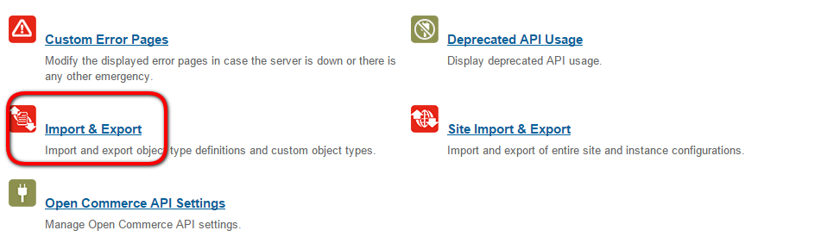
Select the Upload button to upload the kount_metadata.xml file.
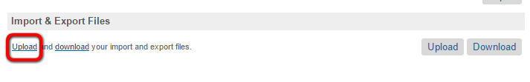
Select the Choose File button and navigate to the kount_metadata.xml file. Select the Upload button.
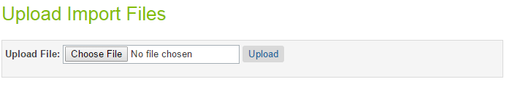
Notice that now the kount_metadata.xml file is listed within the Manage Import Files page.
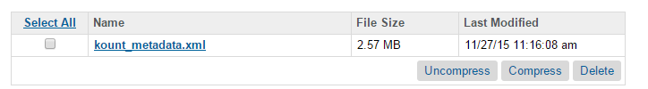
Navigate back to the Import & Export page and select the Import button.
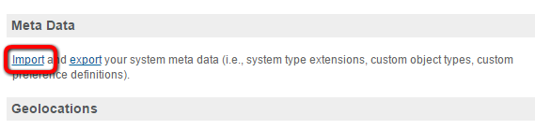
Select the radio button next to the kount_metadata.xml file and choose the Next button. An XML Validation will run.
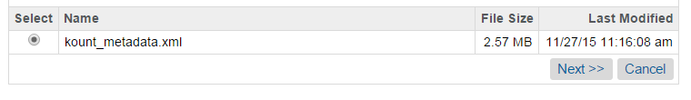

Select the Import button.
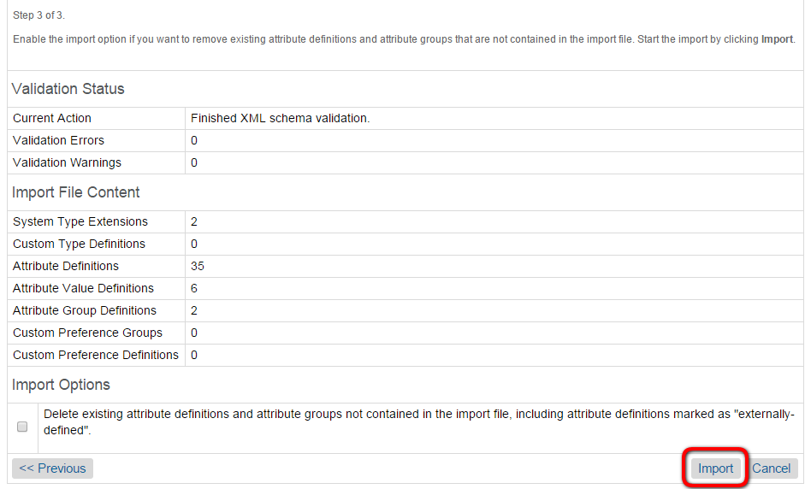
After the import has finished a “Success” status will display.
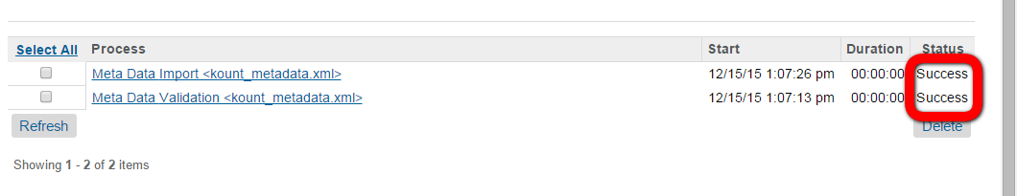
If a Status of Success does not display, check the DW Sandbox Setup (Site Genesis) and attempt the import again.

Step 2 - Create Services
Log into the Business Manager and navigate to Administration > Operations > Services. Navigate to the Profiles tab and choose the New button to create new Profile, name it “kount”.
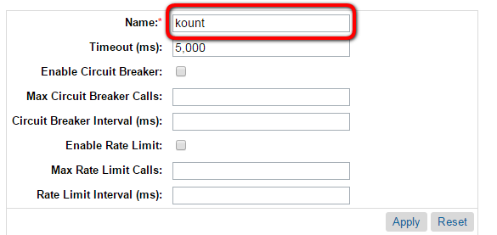
Navigate to the Credentials tab, create a new credentials instance by choosing the New button, name it “kount”.
NOTE: The password field should be left blank.
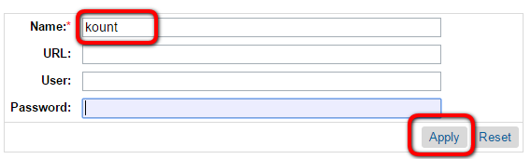
Navigate to the Services tab, create a new service by choosing the New button, name it “kount”. Fill out the additional fields if needed.
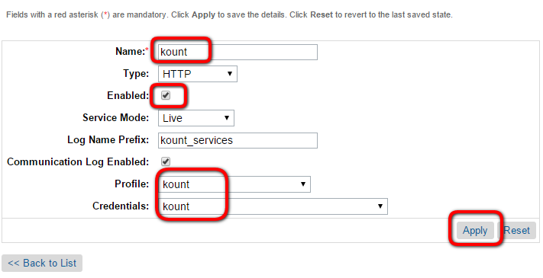

Step 3 - Kount Site Preferences
The Kount Site Preferences will need to be filled into the fields within this page. The script file will display the default values to the right of the screen, but does not populate the fields automatically. Verify the Site Preferences by navigating to Merchant Tools -> Site Preferences -> Custom Preferences. Select Kount.
The Custom Site Preferences page will display. All Sandbox Boarding information needed for this page will be provided by your Kount Technical Account Manager.
Let’s look at the settings page in sections.
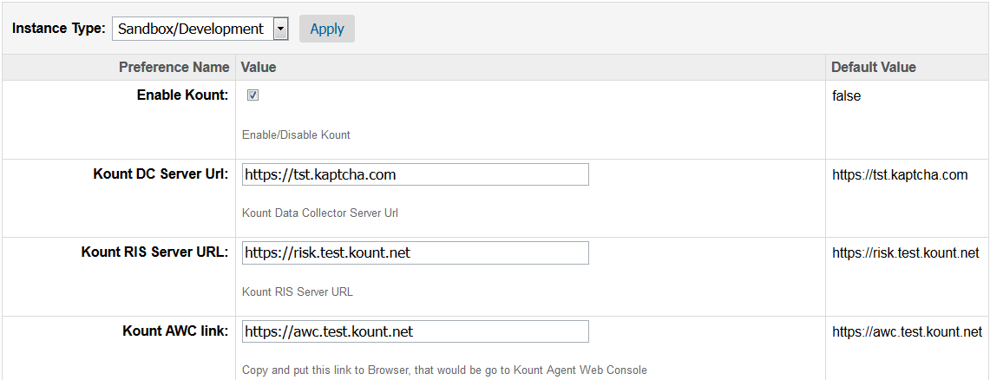

- The Intance Type drop down menu - choose the environment in Demandware.
- Enable Kount – Enables the Kount service to run against orders being passed into the environment.
- The URLs in the next 3 fields are all Test Environment URLs by default. Production URLs are provided when a merchant is certified for produciton traffic, please contact your Technical Account Manager should you need assistance.

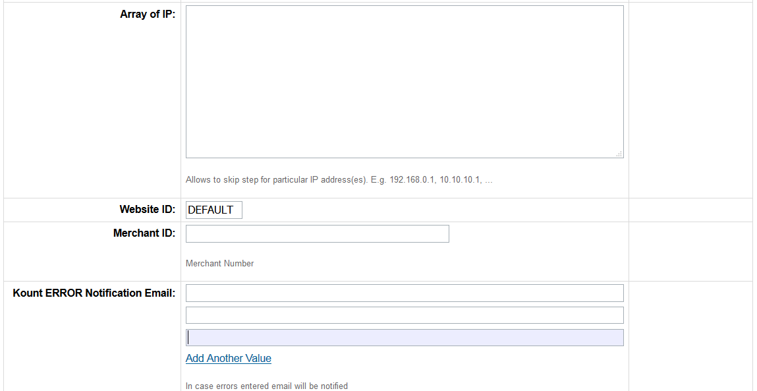
- The Array of IP field is designed for internal IP Addresses that should ignore device data, so for instance if your organization accepts phone orders you will want to enter the internal IP Addresses of the agents who accept those orders so their devices are not attached to the independent orders being taken over the phone.
- Website is typically DEFAULT, although website values can be passed. The corresponding Website values will need to be created inside the AWC (Agent Web Console). To do so, navigate to the Fraud Control tab > Websites.
- Merchant ID or MID value will be provided by your Technical Account Manager.
Note: Kount does not provide email notifications for any events. The Demandware Link Cartridge has the ability to provide email notifications for various features within Demandware, this is not a feature provided by Kount but rather Demandware.
- The “Kount ERROR Notification Email” is a list of email addresses that you would like any errors or warnings sent to that have occurred within Demandware concerning the Kount Link Cartridge. See the Error Logging section of this document for more information about the log files.

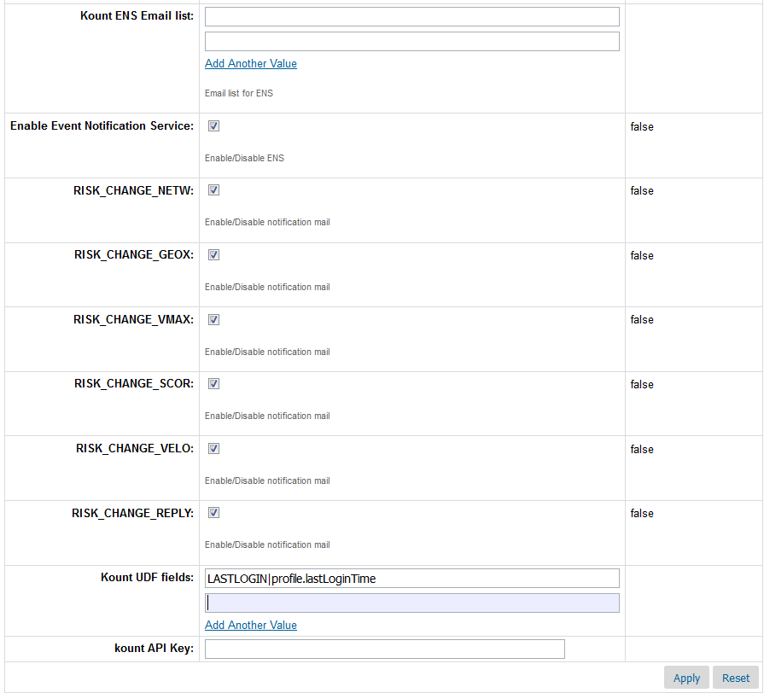
- If you would like email notifications to be sent when ENS events are posted enter an email address in the “Kount ENS Email list” field.
- Enable Event Notification Service (ENS) toggles on or off. The ENS service communicates status changes in Kount to Demandware and updates them within the order. There are additional steps to enabling and configuring ENS please use this link or check the index of this document.
- The next 6 fields are various ENS email notification. If any of these events are triggered an email will be distributed to anyone listed in Email field in the “Kount ENS Email List”.
- UDF (User Defined Fields) can be established in the field. There are additional steps to enabling and configuring UDF values please use this link for instructions.
- This is where the API/RIS Key that was created earlier in this document is enter. Please use this link if you have questions about API/RIS Key creation. Please note the Key will need RIS permissions to function properly.

Step 4 - Assign Cartridge to Site
The Cartridge will need to be assigned to the Merchant’s website & Business Manager.
Navigate to Administration -> Sites -> Manage Sites. Select Kount off the list of Sites, then choose the Settings tab.
Enter the following text into the Cartridges field. int_kount: Be sure to include the colon. Choose the Apply button.
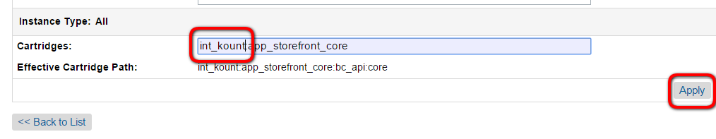
Navigate to Administration -> Sites -> Manage Sites. Scroll down to the Business Manager Section and select the Business Manager site link.
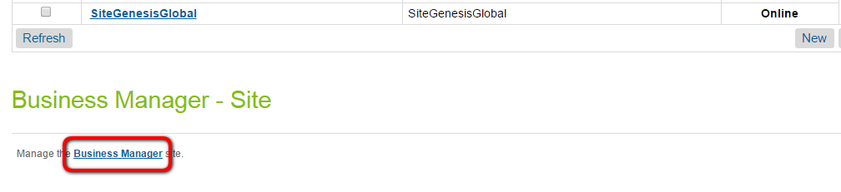
Enter the following text into the Cartridges field. int_kount: Be sure to include the colon. Choose the Apply button.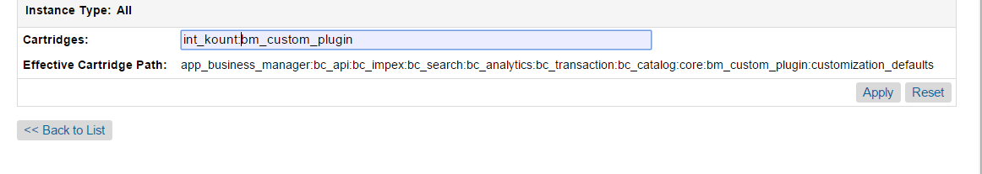

Step 5 - Modify Storefront Code and Pipelines (Custom Coding Requirements)
There are portions of the Kount cartridge implementation that require additions to the internal coding & pipelines of the Demandware storefront code. Please consult with your Demandware development resources to complete this portion of the Kount integration.
NOTE: If your changes are not visible, you may need to reset the code version. To rollback changes to a previous working version. Navigate to Administration > Site Development > Code Deployment. Activate the code version you wish to roll back to.
            - Navigate in Eclipse to your storefront cartridge. Other editors maybe used, the following steps are documented for use with Eclipse. Please reference the Demandware Test Drive documentation for further information.
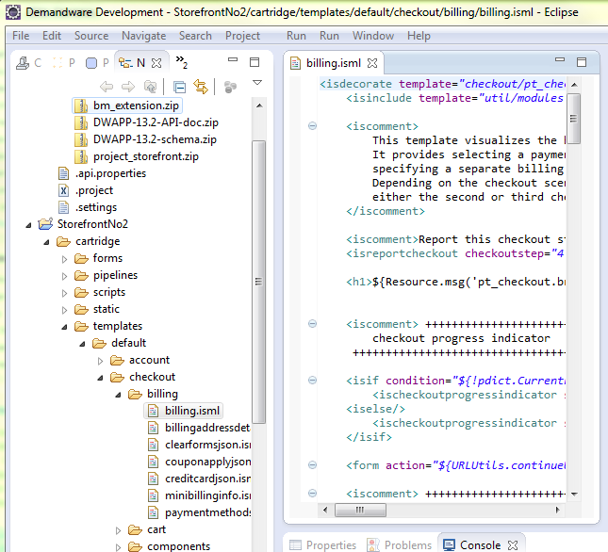
            - Open the Template folder, navigate to checkout/billing/billing.isml (as shown above) and find the billing address line that displayed in the screenshot below.
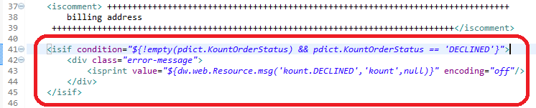
            - Insert these additional lines of code (as shown in the example) and save the file.
<isif condition="${!empty(pdict.KountOrderStatus) && pdict.KountOrderStatus == 'DECLINED'}">
<div class="error-message">
<isprint value="${dw.web.Resource.msg('kount.DECLINED','kount',null)}" encoding="off"/> </div>
</isif>

            - Remaining within the Template folder, navigate to checkout/billing/paymentmethods.isml and find line displayed in the screenshot below. (Tip: Turn on Line No.’s to locate.)
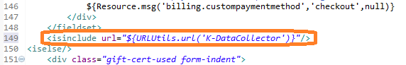
            - Insert the additional line of code (as shown in the example) and save the file.
<isinclude url="${URLUtils.url('K-DataCollector')}"/>
            - Open the Pipeline folder, navigate to COPlaceOrder.xml (Tip: Use Ctrl+Shift+R to search if you are using Eclipse) and insert Call Node, insert the following changes:
- To create the Risk Inquiry Service(RIS) post we must insert K-PostRIS Call Node
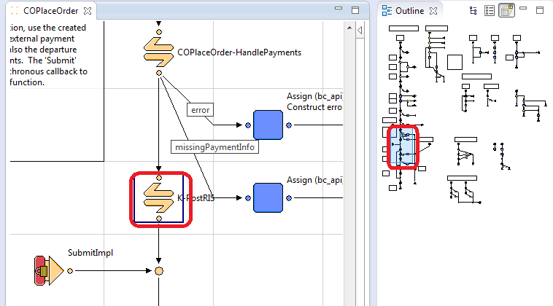

- For GVM for order in case APPROVED request to Kount insert K-CheckKountStatus call node.
Call the addition transition “not_approved”.
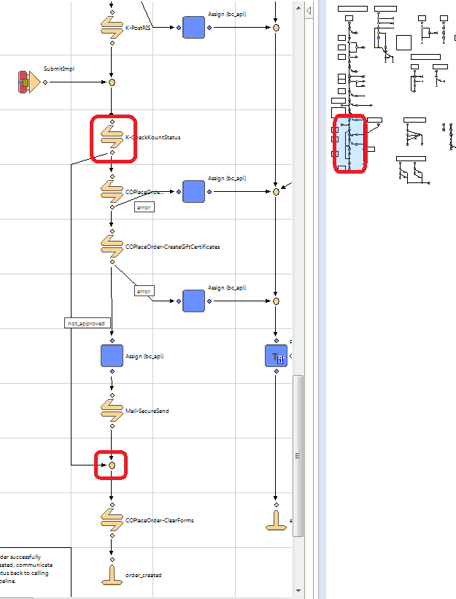

- For update ExportOrderStatus, update script SetOrderStatus.ds with code below and setup input parameter KountOrderStatus(see image below):
SetOrderStatus.ds :
/**
* Set the order export status to EXPORT_STATUS_READY
*
* @input Order : dw.order.Order The order.
* @input KountOrderStatus : String
*/
importPackage( dw.order );

function execute( pdict : PipelineDictionary ) : Number
{
// read pipeline dictionary input parameter
var order : Order = pdict.Order;

// get Kount order status result
var kountOrderStatus : String = pdict.KountOrderStatus;

// Special case if Kount order status is HOLD
if( !empty( kountOrderStatus ) && kountOrderStatus == 'APPROVED' && order.getExportStatus().getDisplayValue() != 'EXPORTED' ) {
order.setExportStatus(Order.EXPORT_STATUS_READY);
} else if( !empty( kountOrderStatus ) && ( kountOrderStatus == 'DECLINED' || kountOrderStatus == 'HOLD' ) ) {
order.setExportStatus(Order.EXPORT_STATUS_NOTEXPORTED);
} else {
// set the export status to EXPORT_STATUS_READY
order.setExportStatus(Order.EXPORT_STATUS_READY);
}

return PIPELET_NEXT;
}

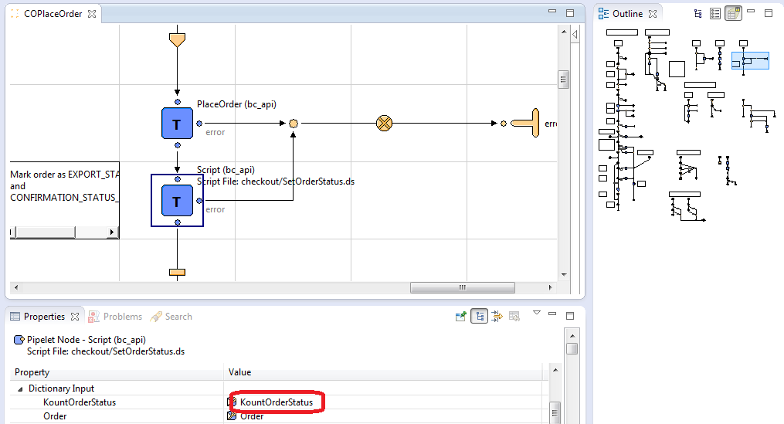

Step 6 – Configure the Event Notification Service (Optional)
To configure the Event Notification Service (ENS) a Merchant URL will need to be set within the Kount Agent Web Console (AWC) and will need to be enabled within the Site Preferences in Demandware (use this link for the location of this setting). All events are sent to the ENS URL as an XML post(s).
Additionally here is the list of IP Addresses that will need to be whitelisted on your server in order to receive the XML posts from Kount:
209.81.12.0/24
64.128.91.0/24
64.128.87.0/24
Below are the steps to setup the ENS (Event Notification System).

- Identify your unique Merchant URL.
Here is an example of an ENS URL:
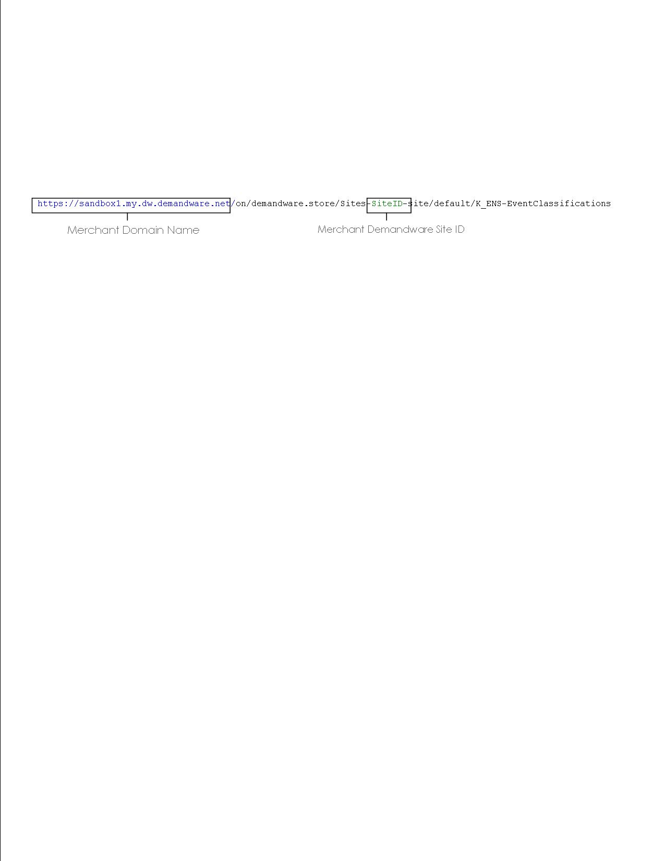
The rest of the URL are static values. Note: The “default” value may be different if the merchant is using another language aside from English.
- Set the ENS URL within Kount. Navigate to the Fraud Control tab > Websites. Select the GEAR, (circled in the image below) and choose Edit.
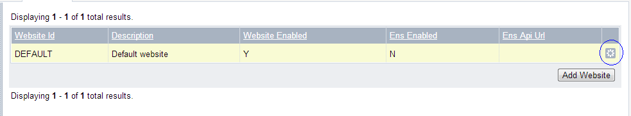
- The “Edit Row” dialog will display. Choose the ENS Enabled radio button. Enter the ENS URL (that is unique to your merchant account) within the Merchant ENS URL field. Select the Update Website button.
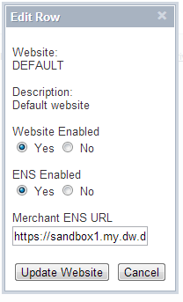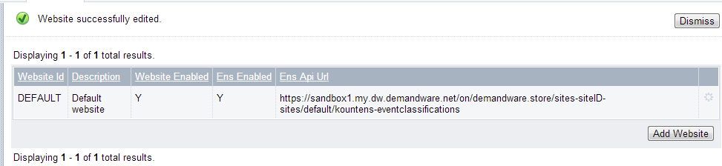
Notice the confirmation in the upper left stating the Website was successfully edited.

External Interfaces (Communication between Kount and Demandware)
The cartridge uses Event Notification System (ENS) for synchronization with the Kount.
Callback Pipelines:
Notifications from Kount are sent to cartridge as a series of events formatted in XML. Handlers for this events are implemented as sub-pipelines described below. One of them (K_ENS-EventClassifications) is an event sorter; it is using the configuration described in Step 6.
- K_ENS- EventClassifications – This is the event sorter determining classification of the event.
- K_ENS- WorkflowStatusEdit, WorkflowReevaluate, RiskChangeScor, RiskChangeReply, RiskChangeVelo, RiskChangeVmax, RiskChangeGeox, RiskChangeNetw, RiskChangeReas - These are the different event handlers.

User Defined Fields Setup and Configuration
The syntax must be formatted to match the values shown in the graphic in order to map correctly within Kount. The System Object Names within Demandware that can be accessed via UDFs are as follows:
Object Name | Label Name | Example Use
Order | order | Date|order.date
Shipping Address | shippingaddress | State|shippingaddress.state
Billing Address | billingaddress | City|billingaddress.city
*Customer Profile | profile | DOB|profile.dob
*Note: Customer Profile Information will be exported in case order was placed by registered customer. System Object Definitions and their attributes can be found within Administration > Site Development > System Object Definitions
DW Data Type | Kount UDF Type
String | Alpha-Numeric
Date | Date
Number | Number

NOTE: The Amount UDF Type is not supported in Demandware at this time. If you wish to support custom objects within Demandware please see the additional section regarding the UDF Map - Modifying the UDF map.

Configuration of User Defined Fields (UDFs) within Kount
(This is an optional portion of the integration.)
Kount provides a way for merchants to include additional information related to their business that may not be a standard field in Kount by creating UDFs. UDFs should be first setup in Kount admin panel. Navigate to the Fraud Control tab > User Defined Fields.
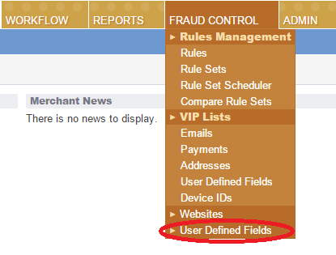
UDF field has type Number by default. In order to change the type, choose the appropriate value using the Type dropdown, (alpha-numeric is the only value that can contribute to the VIP List).
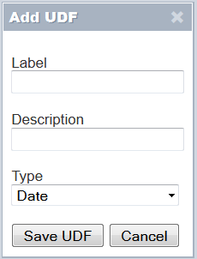
When creating UDFs there may be a few minutes delay from the time of creation to the display within the AWC.

UDF Settings within Demandware Custom Preferences
To pass information into UDFs, navigate within the DW Business Manager to Site Preferences > Custom Preferences. Choose Kount and scroll down to the Kount UDF fields.
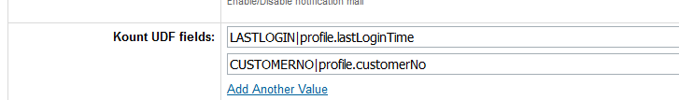

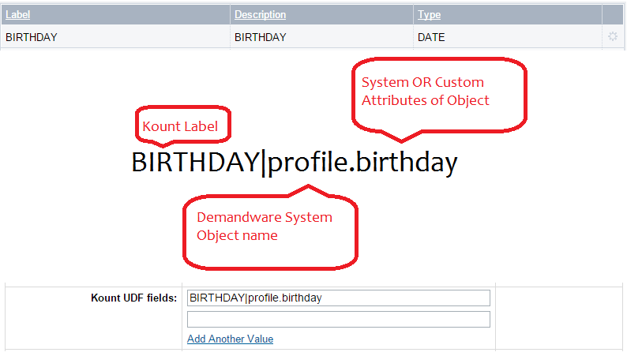

Modifying UDF map within Demandware
To support other Demandware objects an additional mapping should be done in method – getUDFObjectMap in script LibKount.ds
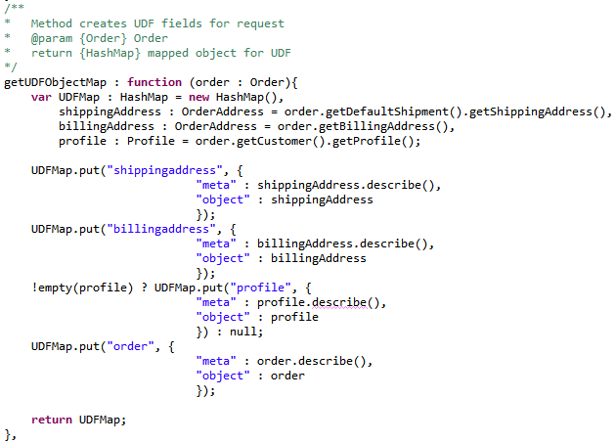
Adding new object to the map should be added in following manner:
UDFMap.put(<label of the object>, {
"meta" : <DW object>.describe(),
"object" : <DW object>
});

Error Logging and Notifications
The Kount Link Cartridge will not interfere with default checkout flow of a site. If an error occurs within the Kount Link Cartridge or if the Kount Service cannot be reached errors are written into separate log files. Here is an example of the Log file naming convention: custom-Kount-blade0-4-appserver-<date stamp>.log
Notifications can also be enabled to deliver email messages to specific addresses if an error were to occur. This link will navigate to the area in the Site Preferences where this can be set.
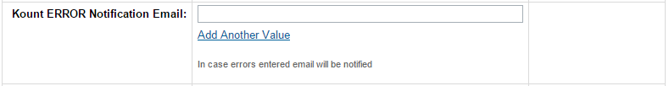

Example of the email body for a Notification Email:
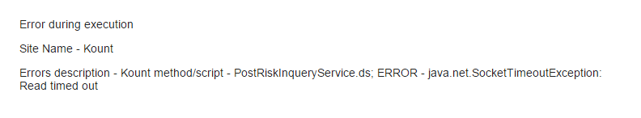

Appendix A: Upgrading/Updating the Link Cartridge
If you have a previous version of Kount Demandware Link Cartridge integrated, you will need perform the following steps to update/upgrade to the latest Link Cartridge.
- Delete the instance of int_kount from eclipse studio. Save all changes and clear the project by navigating to Project > Clean
- Import the latest kount_metadata.xml file provided with the latest instance of the Link Cartridge. Specific instructions are here.
- If you were using 14.x version of the Demandware Link Cartridge, (or older), you will need to use the new Demandware Service Framework. Instructions for adding this service is located here.
- If you were using 14.x version (or older) of the Kount Demandware Link Cartridge you will need to update to the new Kount RIS/API Key to authenticate the RIS HTTPS submission to Kount, (instead of self-signed certificate methodology).
  - Remove the old certificate from Business manager. Navigate to Administration > Operations > Private Keys choose the checkbox next to the certificate and select the Delete button.
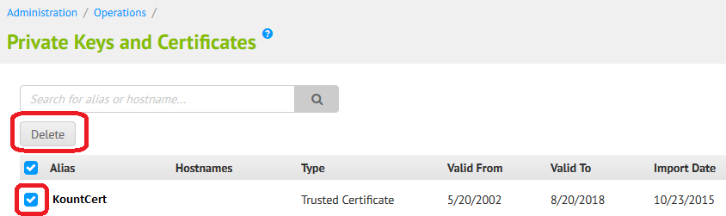
  - Create a Kount RIS/API Key, use the instructions here to create the Key.
  - Copy the RIS/API Key and use the instructions here to insert the new Key value within the Demandware Kount Settings.
- Changes are made to the coding and pipelines with each version of the Demandware Link Cartridge, please review ALL Custom Coding Requirements and update them into the storefront code. Please refer to the release notes for specific changes from version to version of the cartridge.

Appendix B: Demandware Order Workflow
This appendix contains examples of the workflow within a default installation of the Kount Link Cartridge & the expected workflow diagram.
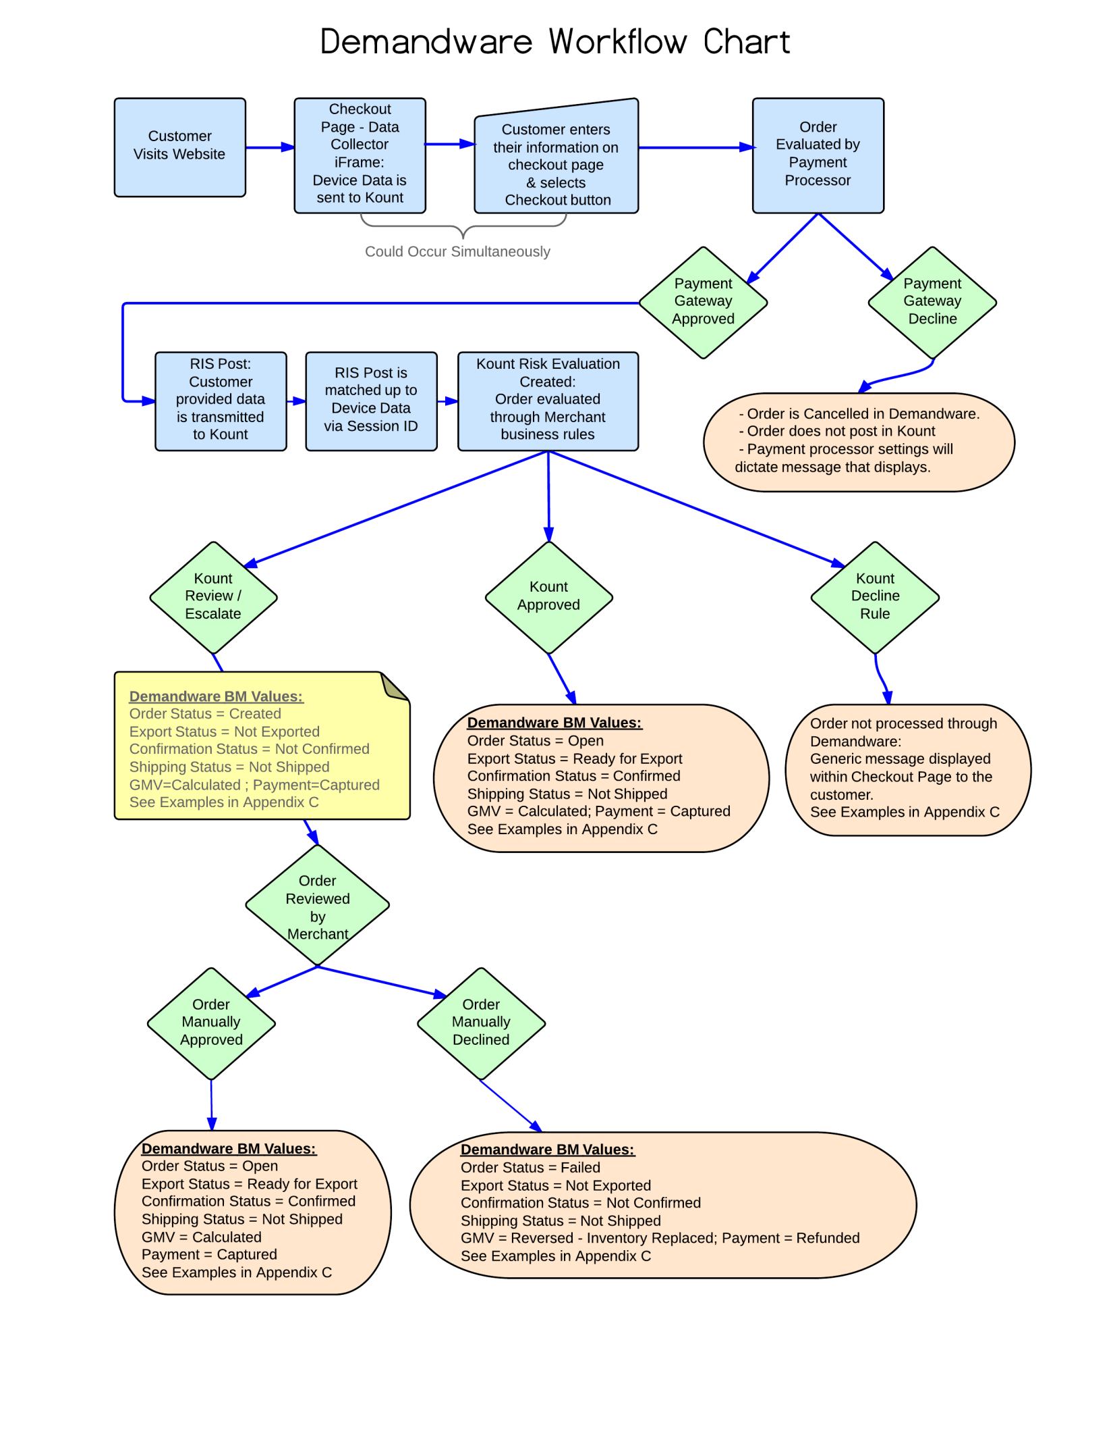

Kount Review/Escalate
This is an example of an order that has triggered a Review or Escalate rule action in Kount.
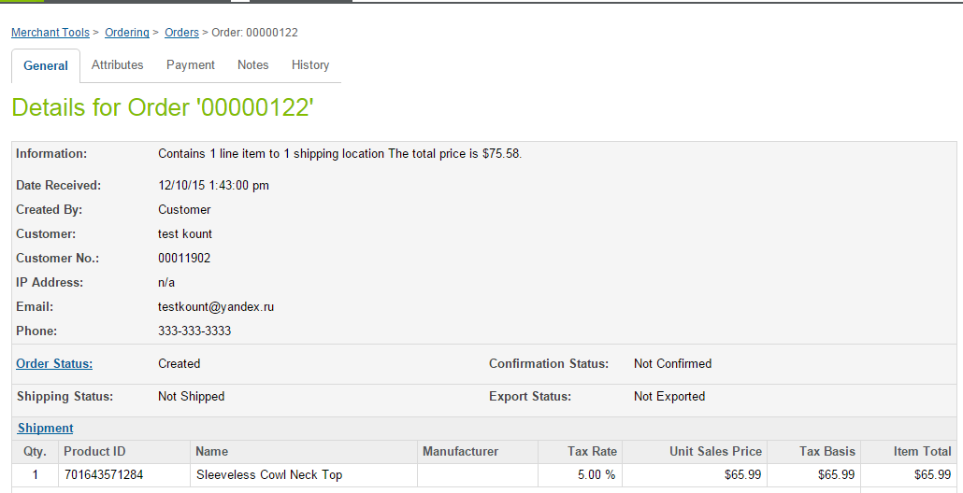
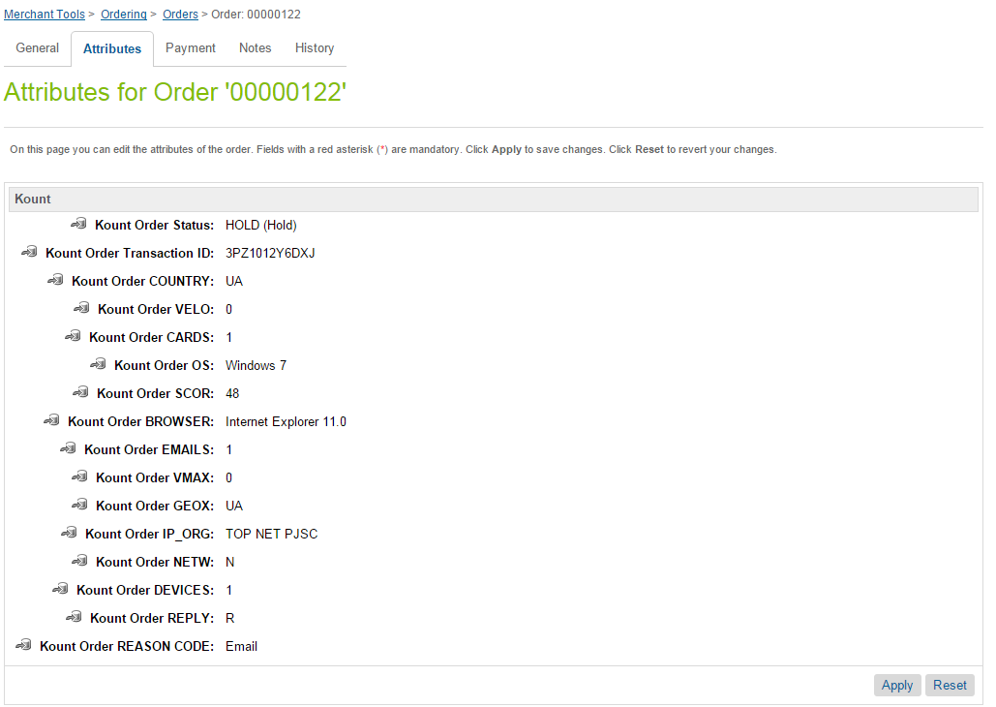

Kount Approved
This is an example of an order that has not triggered a rule or was manually Approved in Kount.
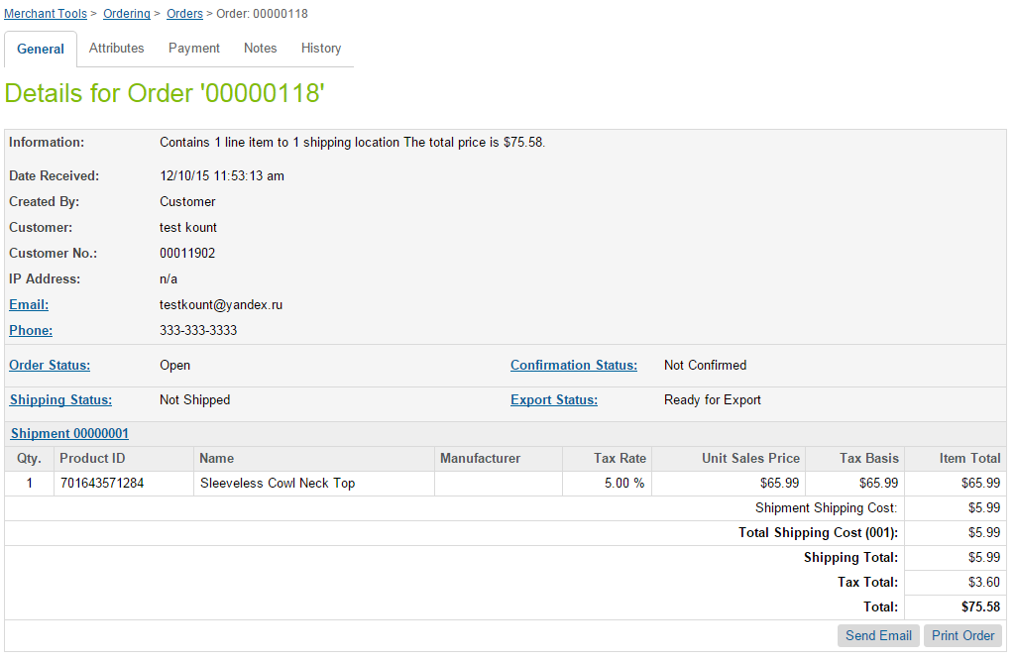
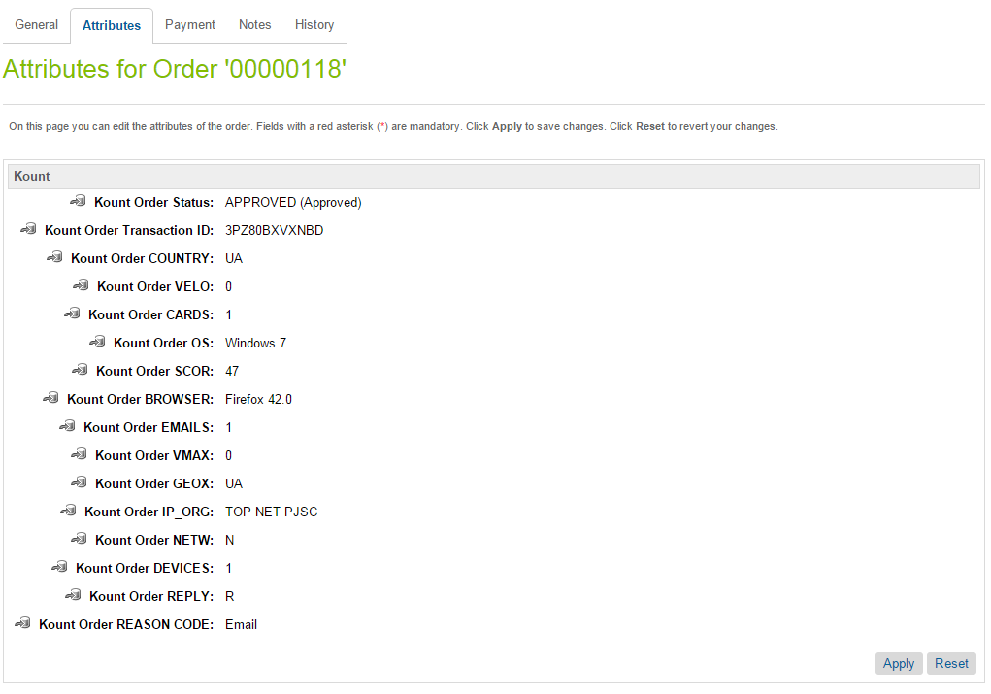

Kount Decline
This is an example of an order that triggered a Decline rule action or was manually Declined in Kount.
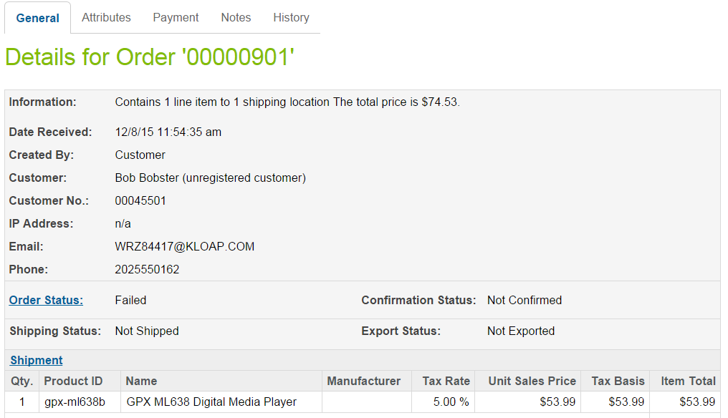
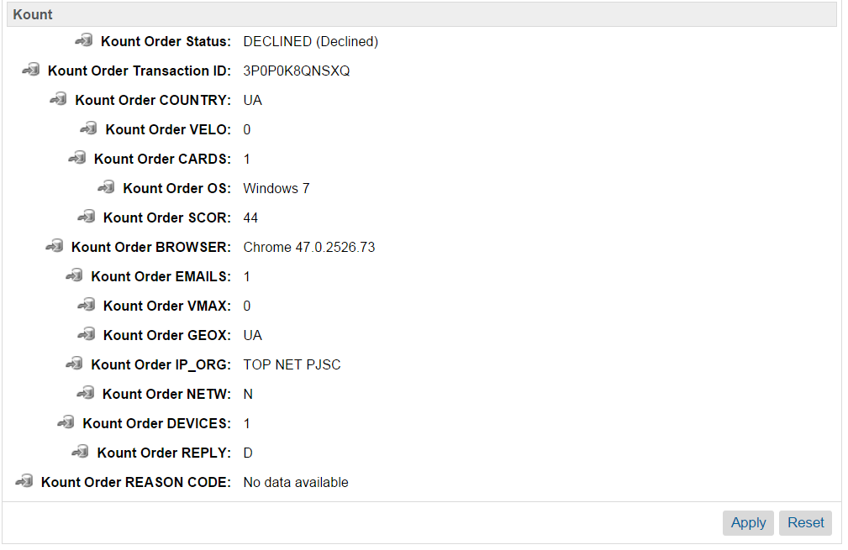

Appendix C: Test Cases

Verifying the Functionality of the Cartridge: Test Cases
Requirements for Test Cases:
- Link to sandbox/test server and Business Manager credentials
- Access to the Kount sandbox/test environment (https://awc.test.kount.net)
- Browser utility installed (like Firebug or another tool), to monitor actions within html code source.

TestCase 1: Verify all fields and choices are present within the Business Manager (BM) after installing the Kount Link Cartridge
- Login to BM, choose the site to verify > Site Preferences > Custom Preferences > Kount.
- Verify the following components are available and set:
- Enable Kount checkbox
- Kount DC Server URL field
- Kount RIS Server URL field
- Kount AWC link field
- Array of IP (text area)
- Website ID field
- Merchant ID field
- Kount ERROR Notification (Email field(s))
- Kount ENS Email list (Email field(s))
- Enable Event Notification Service checkbox
- RISK_CHANGE_NETW checkbox
- RISK_CHANGE_GEOX checkbox
- RISK_CHANGE_VMAX checkbox
- RISK_CHANGE_SCOR checkbox
- RISK_CHANGE_VELO checkbox
- RISK_CHANGE_REPLY checkbox
- Kount UDF field(s)
- Kount API Key
- Apply and Reset buttons

TestCase 2: Verify the Attributes values within the Order Attributes tab within the Business Manager (BM).
- Login to BM, choose the site to verify > Ordering > Orders
- Choose the Find button
- Open Attributes tab
- Verify the Kount Order Status displays with one of the following values.
- Approved
- Hold
- Declined
- Change
- Time out
- Time out payment
- Verify the following fields display with values.
- Kount Order Transaction ID
- Kount Order GEOX
- Kount Order NETW
- Kount Order SCOR
- Kount Order VELO
- Kount Order VMAX
- Kount Order BROWSER
- Kount Order OS
- Kount Order IP_ORG
- Kount Order CARDS
- Kount Order EMAILS
- Kount Order DEVICES
- Kount Order COUNTRY
- Kount Order REPLY

TestCase 3: Testing the Functionality of the iFrame
Prerequisites:
  - Login to BM and choose the site to verify > Site Preferences > Custom Preferences > Kount
  - Verify the Kount DC Server URUL is set to: https://tst.kaptcha.com
  - Apply changes.
- Open Store Front instance of Demandware and place items in the cart.
- Start Checkout as Guest.
- Enter a shipping address, select shipping method and click Continue button
- Scroll down Billing page
- Verify that in the bottom left corner of the page there is a pixel (little blue rectangle)
- Right Click on pixel and choose Inspect Element
- Verify that pixel is defined as a div with class iframe_test and is contained inside the iframe component
- Using prompt in the Prerequisites set: Set Kount DC Server Url: https://tst.kaptcha.com
- Open the Billing page again and verify that pixel is not visible (the little blue rectangle is absent)
- Open the page sources (e.g. using Firebug) and search for the iframe
- Verify that iframe component is still there and div around it is without the test class

TestCase 4: Verify internal orders do not collect Device Data via the iFrame
Prerequisites:
  - Login to BM and choose the site to verify > Site Preferences > Custom Preferences > Kount
  - Verify the Kount DC Server URUL is set to: https://tst.kaptcha.com
  - Enter your current public IP Address to Array of IP field
  - Apply changes
- Open Store Front instance of Demandware and place items in the cart
- Start Checkout as Guest
- Enter a shipping address, select shipping method and click Continue button
- Scroll down Billing page
- Verify that in the bottom left corner of the page there is NOT a pixel (little blue rectangle)
- Open the page sources and search for iframe
- Verify that there is no available iframe component on page (there will be a disabled one, with id="_atssh")
- Select or enter a billing address, enter payment data and click Continue button, submit the order
- Open the order within the BM (Login to BM, choose the site to verify > Ordering > Orders)
- Navigate to the Attributes tab and verify that Kount Order COUNTRY value is “No data available”

TestCase 5: Session ID values for both iFrame collection and HTTPS RIS post are matching
Prerequisites:
  - Login to BM and choose the site to verify > Site Preferences > Custom Preferences > Kount
  - Verify the Kount DC Server URUL is set to: https://tst.kaptcha.com
  - Apply changes.
- Open Store Front instance of Demandware and place items in the cart
- Start Checkout as Guest
- Enter a shipping address, select shipping method and click Continue button
- Scroll down Billing page
- Verify that in the bottom left corner of the page there is a pixel (little blue rectangle)
- Right Click on pixel choose Inspect Element
- Verify the iFrame component src parameter and collect the value (within Notepad, screenshot, etc.) after “s=”
an example would look like this: s=45TaxQ66Yp5Bhn4I_EvN2pY0bc1qMiaa
- Select/Enter a billing address, enter payment data and click Continue button. Submit the Order
- Login to Kount and open Reports > Order Search.
10. Using Start Date, find your report and click “details” link.
11. Verify that Session ID, which is in Transaction Summary is as in iframe.

Test Case 6: Send data to Kount. Check that guest user and order data sent correctly to Kount.
Steps:
1. Open Store Front.
2. Choose some product, add it to Cart and start Checkout as Guest.
3. On Shipping page enter a shipping address, select shipping method and Continue checkout.
4. Select or enter a billing address, enter payment data and click Continue button.
5. Submit Order.
6. Login to Kount and open Reports > Order Search.
7. Using Start Date, find your report and click “details” link.
8. Verify that next data sent correctly:
- Transactional Summary section: Date, Order Num
- Customer: Created, Name, Email, Ship Email, Cust. ID (empty)
- Payment: Total, Type
- Device: Location, IP Address (to find out you address can use e.g. can use http://www.myipaddress.com)
- Addresses: Billing Address, Shipping Address
- Phone Numbers: Billing Phone, Shipping Phone
- Shopping Cart
- Bank Information

TestCase 7: Send data to Kount. Check that registered user and order data sent correctly to Kount.
Steps:
1. Open Store Front.
2. Login as registered user (or register a new one).
3. Choose some product, add it to Cart and start Checkout.
4. On Shipping page enter a shipping address, select shipping method and Continue checkout.
5. Select or enter a billing address, enter payment data and click Continue button.
6. Submit Order.
7. Login to Kount and open Reports > Order Search.
8. Using Start Date, find your report and click “details” link.
9. Verify that next data sent correctly:
- Transactional Summary section: Date, Order Num
- Customer: Created, Name, Email, Ship Email, Cust. ID
- Payment: Total, Type
- Device: Location, IP Address (to find out you address can use e.g. can use http://www.myipaddress.com)
- Addresses: Billing Address, Shipping Address
- Phone Numbers: Billing Phone, Shipping Phone
- Shopping Cart
- Bank Information
TestCase 8.: Decline Order. Check that declined order return user to billing page with proper message.
Prerequisites:
Set Rules on Kount that will decline orders :
- Login to Kount
- Open Fraud Control -> Rule Sets
- Copy Rule Set and make all rules action to Declined.
- Open Rule Set and click Activate Rule Set.
So each order which come to Kount will become Declined.

Steps:
1. Open Store Front.
2. Login as registered user (or register a new one).
3. Choose some product, add it to Cart and start Checkout.
4. On Shipping page enter a shipping address, select shipping method and Continue checkout.
5. Select or enter a billing address, enter payment data and click Continue button.
6. Submit Order.
7. Verify that you redirected to billing page and “We were unable to process your transaction at this time. Please contact customer support.” notification message appeared.

TestCase 9: Workflow Reevaluate. Check that order status changed in OMS (BM), when it changed on Kount.
Prerequisites:
Need to enable ENS:
- Login to BM and open Kount > Site Preferences > Custom Preferences > Kount.
- Check Enable Event Notification Service checkbox.
- Apply changes.

Steps:
1. Open Store Front.
2. Login as registered user (or register a new one).
3. Choose some product, add it to Cart and start Checkout.
4. On Shipping page enter a shipping address, select shipping method and Continue checkout.
5. Select or enter a billing address, enter payment data and click Continue button.
6. Submit Order.
7. Login to Kount and open Reports > Order Search.
8. Using Start Date, find your report and click “details” link.
9. Verify order status and Transaction ID.
10. Login to BM and open Kount > Ordering > Orders > Find and open your order.
11. Open Attributes tab and verify that order status, Transaction ID have the same values as on Kount.
12. Again open order on Kount and change it status using form in the bottom of page.
13. Open order in BM and verify that order status changed.

TestCase 10: Risk Change Score. Check that order risk evaluation changed OMS (BM), when it changed on Kount.
Prerequisites:
Need to enable ENS:
- Login to BM and open Kount > Site Preferences > Custom Preferences > Kount.
- Check Enable Event Notification Service checkbox.
- Apply changes.

Steps:
1. Open Store Front.
2. Login as registered user (or register a new one).
3. Choose some product, add it to Cart and start Checkout.
4. On Shipping page enter a shipping address, select shipping method and Continue checkout.
5. Select or enter a billing address, enter payment data and click Continue button.
6. Submit Order.
7. Login to Kount and open Reports > Order Search
8. Using Start Date, find your report
9. Click “details” link.
10. Verify data in Current Risk Evaluation block.
11. Login to BM and open Kount > Ordering > Orders > Find and open your order.
12. Open Attributes tab and verify that order status, Transaction ID have the same values as on Kount.
13. Make the XML posts for the RISK EVENT changes and the Reevaluate change events.
14. Open order in BM and verify that order RISK EVENT attribute changed.

TestCase 11. Additional Payment Types verification
1. Open Store Front.
2. Choose some product, add it to Cart and start Checkout as Guest.
3. On Shipping page enter a shipping address, select shipping method and Continue checkout.
4. Select or enter a billing address, enter different payment method, fill correct data (important for PayPal) and click Continue button.
5. Submit Order.
6. Login to Kount and open Reports > Order Search.
7. Using Start Date, find your report and click “details” link.
8. Verify that next data sent correctly:
- In case PayPal used – on Kount should be PayPal
- In case Credit Card + Pay Pal used – on Kount should be Credit Card
- In case Gift card used – on Kount should be Gift card
- In case Gift card + Credit Card used – on Kount should be Credit Card
- In case Gift card + Pay Pal used – on Kount should be PayPal

TestCase 12. User Defined Fields verification
1. Login to BM and open Kount > Site Preferences > Custom Preferences > Kount
2. Setup UDF fields in Demandware instance. Fill 'Kount UDF fields' field with 3 values:
- for Order DW object (e.g. TESTUDF1|order.Order Attribute Definition ID)
- for OrderAddress DW object (e.g. TESTUDF2|shippingaddress.OrderAddress Attribute Definition ID)
- for Profile DW object (e.g. TESTUDF3|profile.Profile Attribute Definition ID)
3. In Kount admin set 3 UDF fields (same as for #2)
4. Open Store Front.
5. Choose some product, add it to Cart and start Checkout.
6. On Shipping page enter a shipping address, select shipping method and Continue checkout.
7. Select or enter a billing address, enter payment data and click Continue button.
8. Submit Order.
9. In Kount admin verify UDF fields values for placed order.
10. Login to BM and open Kount > Site Preferences > Custom Preferences > Kount
11. Change UDF to have not correct values.
- for Order DW object (e.g. TESTUDF1|xxx.Order Attribute Definition ID)
12. Open Store Front.
13. Choose some product, add it to Cart and start Checkout.
14. On Shipping page enter a shipping address, select shipping method and Continue checkout.
15. Select or enter a billing address, enter payment data and click Continue button.
16. Submit Order.
17 Data for incorrect UDF is not sent to Kount.
18. Error is occured, Log file contains appropriate info about error in custom - <kount> - <hostname> - appserver - <creation date of the file in GMT>.log
19. Login to BM and open Kount > Site Preferences > Custom Preferences > Kount
20. Change UDF to have correct values.
- for Order DW object (e.g. TESTUDF1|order.Order Attribute Definition ID)
21. In Kount admin panel delete TESTUDF1.
22. Open Store Front.
23. Choose some product, add it to Cart and start Checkout.
24. On Shipping page enter a shipping address, select shipping method and Continue checkout.
25. Select or enter a billing address, enter payment data and click Continue button.
26. Submit Order.
27. Data for TESTUDF1 is not sent to Kount.
28. Error is occured, Log file contains appropriate info about error in custom - <kount> - <hostname> - appserver - <creation date of the file in GMT>.log

TestCase 13. Errors logging and email notification verification
1. Login to BM and open Kount > Site Preferences > Custom Preferences > Kount
2. Fill 'Kount Notification Email' field with 2 e-mails.
3. Сreate a test situation when Kount service is unavailable
- Wrong UDF field value.
4. Open Store Front.
5. Choose some product, add it to Cart and start Checkout.
6. On Shipping page enter a shipping address, select shipping method and Continue checkout.
7. Select or enter a billing address, enter payment data and click Continue button.
8. Submit Order.
9. Login to BM and open Administration > Site Development > Development Setup > Open Logs folder
10. Verify separate log file availability: custom - <kount> - <hostname> - appserver - <creation date of the file in GMT>.log
11. Verify log file content has following format: [error time in GMT] <error type> <system description> <custom description>
12. Go to mail boxes .
13. Verify e-mail availability for each e-mail box. Recipient data will contain the following:
from - noreply@noreply.com
to - value from site preferences
cc - empty
bcc - empty

TestCase 14: Risk Change Score. Check that email with old and new Evaluation data receiving, when Risk and Reevaluation events changed.
Prerequisites:
Need to enable ENS:
- Login to BM and open Kount > Site Preferences > Custom Preferences > Kount.
- Check Enable Event Notification Service checkbox.
- Add your email to Kount Email list
- Check checkbox for all RISK_CHANGE parameters
- Apply changes.

Steps:
1. Open Store Front.
2. Login as registered user (or register a new one).
3. Choose some product, add it to Cart and start Checkout.
4. On Shipping page enter a shipping address, select shipping method and Continue checkout.
5. Select or enter a billing address, enter payment data and click Continue button.
6. Submit Order.
7. Login to Kount and open Reports > Order Search
8. Using Start Date, find your report
9. Click “details” link.
10. Verify data in Current Risk Evaluation block.
11. Login to BM and open Kount > Ordering > Orders > Find and open your order.
12. Make the XML posts for the RISK EVENT changes and the Reevaluate change events.
13. Open your email box.
14. Verify availability of e-mail with old and new Risk Evaluation data.

Appendix D: Legacy Certificate Creation
A RIS Certificate must be created, converted and imported into the Demandware Business Manager. See Appendix D for Certificate Export instructions.
Note: The following instructions assume that:
- A X.509 Self Signed certificate has been created from the Agent Web Console.
- OpenSSL has been installed with no additional libraries
- The original .p12 or .pfx file reside within the OpenSSL directory (no friendly pathing).
- Convert the original .p12 to a .pem format certificate using the following command line instruction from OpenSSL.
Enter the password used to create the file during the initial export of the certificate from the browser. A “MAC verified OK” message will display if the password was entered correctly.
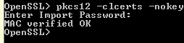
- To import the converted certificate and original .p12 or .pfx private key file into the Business Manager navigate to Administration -> Operations -> Private Keys and Certificates.
- Select the Import button (as shown below).
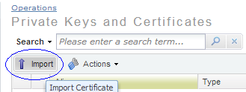
- Browse to the location of the converted pem certificate file. Enter https://risk.test.kount.net within the Alias field. Select the Import button.
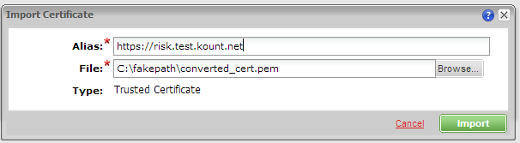

- Select the Import button again.
- Browse to the original .p12 or .pfx file that was exported from the browser.
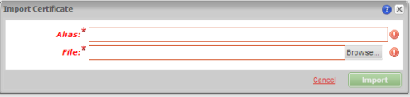

As soon as you open the .p12 or .pfx file the dialog box will change. Enter ris_private_key within the Alias field. Enter the password that was used to create the certificate. Enter https://risk.test.kount.net within the Host Names field and choose the ADD button similar to the image below. Select the Import button.
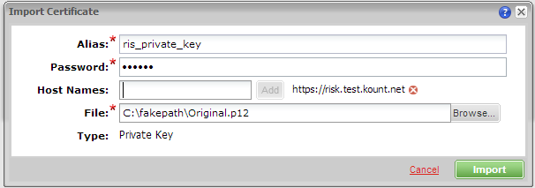
The Private Keys and Certificates will display below with grayed out dates and import confirmation until the Demandware Sandbox is rebooted. The Demandware Sandbox automatically reboots every night.
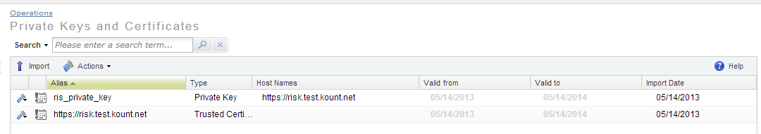

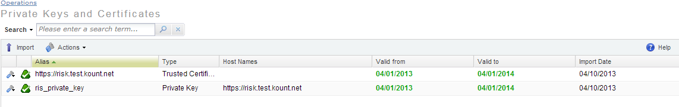
Below is how the Private Key and Certificate will display after the Demandware Sandbox has been rebooted.

To preserve the security of RIS data, merchants must authenticate to RIS using an X.509 certificate when submitting RIS requests. Certificates are exported via a browser. Additional details regarding the certificate are found in the SDK Guide.
Supported Browsers for certificate exportation:
 Microsoft Internet Explorer version 7 and newer (must be in compatibility mode for IE 10).
 Mozilla Firefox version 5 and newer
 Apple Safari

NOTE: Google Chrome does not support the exportation of certificates.

Firefox

Certificate Request:
Requesting a Certificate using Mozilla Firefox

- From https://awc.kount.net/login.html, select the ADMIN tab, RIS Certificates.

- Choose the Request RIS Certificate button at the bottom right of the RIS Certificate page.

- The Request RIS Certificate dialog will display. Enter a unique name and select the Request Certificate button.
- The Alert pop-up will display. Select the OK button. (Close the Request RIS Certificate dialog box, (it remains open by default).

Certificate Export:

- From the Firefox web browser toolbar, Select Options, Options.

- The Options dialog will display, select the Advanced icon. Choose the Encryption tab, and View Certificates button.

- The Certificate Manager dialog will display. Select the certificate created earlier from the Your Certificates tab. Select the Backup button.

- The File Name to Backup dialog will display. Select a location to save the certificate file. Enter a unique name. The default file format is PKCS12 Files (*.p12). Select the Save button.

- The Choose a Certificate Backup Password dialog will display. Enter a password for the certificate backup in the Certificate backup password field, enter the same password again in the Certificate backup password (again) field, and select the OK button.

- The Alert dialog indicating that the certificate and private key have been successfully backed up will display. Select the OK button.

Appendix E: Manual Integration Steps
Create System Object Definitions (manual integration method)
1. Create the following system object definitions:
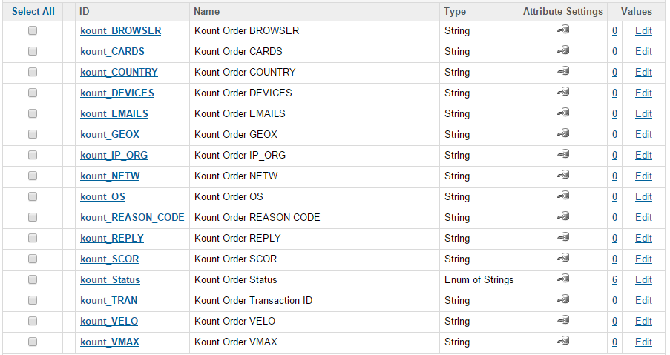
- Order
  - Kount Order Status
    - id: kount_Status
    - display name: Kount Order Status
    - type: Enum of Strings
    - mandatory: false
    - externally managed: true
    - values:
      - value: APPROVED, display value: Approved
      - value: HOLD, display value: Hold
      - value: DECLINED, display value: Declined
      - value: CHANGE, display value: Change
      - value: TIME OUT, display value: Time Out
      - value: TIME OUT PAYMENT, display value: Time Out Payment Authorization
  - Kount Order NETW
    - id: kount_NETW
    - display name: Kount Order NETW
    - type: String
    - mandatory: false
    - externally managed: true
  - Kount Order GEOX
    - id: kount_GEOX
    - display name: Kount Order GEOX
    - type: String
    - mandatory: false
    - externally managed: true
  - Kount Order SCOR
    - id: kount_SCOR
    - display name: Kount Order SCOR
    - type: String
    - mandatory: false
    - externally managed: true
  - Kount Order TRAN
    - id: kount_TRAN
    - display name: Kount Order TRAN
    - type: String
    - mandatory: false
    - externally managed: true
  - Kount Order VELO
    - id: kount_VELO
    - display name: Kount Order VELO
    - type: String
    - mandatory: false
    - externally managed: true
  - Kount Order VMAX
    - id: kount_VMAX
    - display name: Kount Order VMAX
    - type: String
    - mandatory: false
    - externally managed: true
  - Kount Order Browser
    - id: kount_BROWSER
    - display name: Kount Order BROWSER
    - type: String
    - mandatory: false
    - externally managed: true
  - Kount Order OS
    - id: kount_OS
    - display name: Kount Order OS
    - type: String
    - mandatory: false
    - externally managed: true
  - Kount Order IP_ORG
    - id: kount_IP_ORG
    - display name: Kount Order IP_ORG
    - type: String
    - mandatory: false
    - externally managed: true
  - Kount Order Cards
    - id: kount_CARDS
    - display name: Kount Order CARDS
    - type: String
    - mandatory: false
    - externally managed: true
  - Kount Order DEVICES
    - id: kount_DEVICES
    - display name: Kount Order DEVICES
    - type: String
    - mandatory: false
    - externally managed: true
  - Kount Order COUNTRY
    - id: kount_COUNTRY
    - display name: Kount Order COUNTRY
    - type: String
    - mandatory: false
    - externally managed: true
  - Kount Order EMAILS
    - id: kount_EMAILS
    - display name: Kount Order EMAILS
    - type: String
    - mandatory: false
    - externally managed: true
  - Kount Order REASON CODE
    - id: kount_REASON_CODE
    - display name: Kount Order REASON CODE
    - type: String
    - mandatory: false
    - externally managed: true

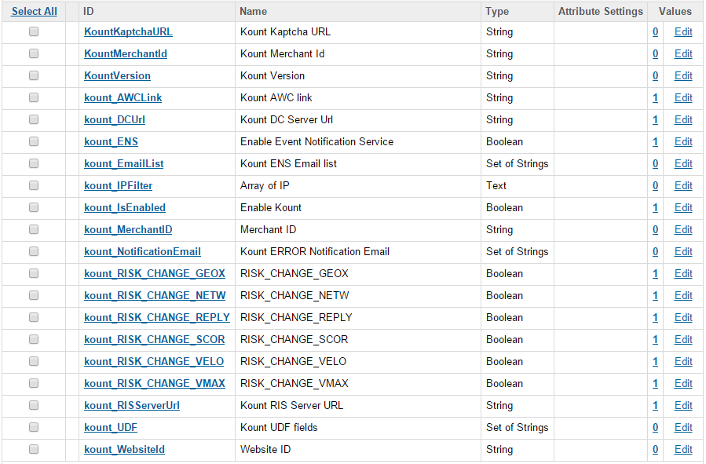
- Site Preferences
  - Enable Kount
    - id: kount_IsEnabled
    - display name: Enable Kount
    - type: Boolean
    - mandatory: false
  - Kount DC Server Url
    - id: kount_DCUrl
    - display name: Kount DC Server Url
    - description: Kount Data Collector Server Url.
    - type: String
    - mandatory: false
    - default value: https://tst.kaptcha.com
  - Kount RIS Server URL
    - id: kount_RISServerUrl
    - display name: Kount RIS Server URL
    - description: Kount RIS Server URL
    - type: String
    - mandatory: false
    - default value: https://risk.test.kount.net
  - Array of IP
    - id: kount_IPFilter
    - display name: Array of IP
    - description: Allows to skip step for particular IP address(es). E.g. 192.168.0.1, 10.10.10.1, ...
    - type: Text
    - mandatory: false
  - Website ID
    - id: kount_WebsiteId
    - display name: Website ID
    - type: String
    - mandatory: false
    - minimum value: 1
    - field length: 8
  - Merchant ID
    - id: kount_MerchantID
    - display name: Merchant ID
    - description: Merchant Number
    - type: String
    - mandatory: false
  - Kount AWC link
    - id: kount_AWCLink
    - display name: Kount AWC link
    - description: Copy and put this link to Browser, that would be go to Kount Agent Web Console
    - type: String
    - mandatory: false
    - default value: https://awc.test.kount.net
  - Enable Event Notification Service
    - id: kount_ENS
    - display name: Enable Event Notification Service
    - description: Enable/Disable ENS
    - type: Boolean
    - mandatory: false
  - Kount ENS Email list
    - id: kount_EmailList
    - display name: Kount ENS Email list
    - description: Email list for ENS
    - type: Set of String
    - mandatory: false
  - Kount ERROR Notification Email
    - id: kount_NotificationEmail
    - display name: Kount ERROR Notification Emai
    - description: In case errors entered email will be notified
    - type: Set of String
    - mandatory: false
  - RISK_CHANGE_GEOX
    - id: kount_RISK_CHANGE_GEOX
    - display name: Kount Email list
    - description: Enable/Disable notification mail
    - type: Boolean
    - mandatory: false
  - RISK_CHANGE_NETW
    - id: kount_RISK_CHANGE_NETW
    - display name: Kount Email list
    - description: Enable/Disable notification mail
    - type: Boolean
    - mandatory: false
  - RISK_CHANGE_REAS
    - id: kount_RISK_CHANGE_REAS
    - display name: Kount Email list
    - description: Enable/Disable notification mail
    - type: Boolean
    - mandatory: false
  - RISK_CHANGE_REPLY
    - id: kount_RISK_CHANGE_REPLY
    - display name: Kount Email list
    - description: Enable/Disable notification mail
    - type: Boolean
    - mandatory: false
  - RISK_CHANGE_SCOR
    - id: kount_RISK_CHANGE_SCOR
    - display name: Kount Email list
    - description: Enable/Disable notification mail
    - type: Boolean
    - mandatory: false
  - RISK_CHANGE_VELO
    - id: kount_RISK_CHANGE_VELO
    - display name: Kount Email list
    - description: Enable/Disable notification mail
    - type: Boolean
    - mandatory: false
  - RISK_CHANGE_VMAX
    - id: kount_RISK_CHANGE_VMAX
    - display name: Kount Email list
    - description: Enable/Disable notification mail
    - type: Boolean
    - mandatory: false
  - Kount UDF fields id:
    - Id: kount_UDF
    - display name: Kount UDF Fields
    - description: Kount UDF Fields
    - type: Set of String
    - mandatory: false
  - Kount API Key:
    - Id: kount_APIKey
    - display name: kount API Key
    - type: String
    - mandatory: false

2. Create an attribute group for Kount site preferences and add fields.
- id: Kount
- display name: Kount
- attributes:
  - kount_IsEnabled
  - kount_DCUrl
  - kount_RISServerUrl
  - kount_IPFilter
  - kount_WebsiteId
  - kount_MerchantID
  - kount_AWCLink
  - kount_ENS
  - kount_EmailList
  - kount_RISK_CHANGE_NETW
  - kount_RISK_CHANGE_GEOX
  - kount_RISK_CHANGE_VMAX
  - kount_RISK_CHANGE_SCOR
  - kount_RISK_CHANGE_VELO
  - kount_RISK_CHANGE_REPLY
  - kount_UDF
  - kount_NotificationEmail
  - kount_APIKey

